MS.NET
Mini Project
Online Recruitment System
(ORS)

Document Revision History

Date | Revision No. | Author | Summary of Changes
20th Nov. 2008 | 1 | Ganesh Desai | Initial Draft
15th Dec 2008 | 1 | Anil Patil | Review
25th July 2011 | 1 | Karthik | Review after integration Process
11th May 2015 | 1 | Vaishali Kasture | Implementing changes as per new curriculum
13th July 2016 | 1 | Vijay Vishwakarma | Incorporating changes as per new curriculum

Table of Contents
Introduction 4
Setup Checklist 4
Instructions 4
Problem Statement 5
Objective 5
Abstract of the project 5
Functional components of the project 6
Technology used: 7
Implementation 8
Summary of the functionality to be built: 8
Guidelines on the functionality to be built: 9

Introduction

This document outlines a mini project for the .NET Line of Technology (LOT). The project is to develop online Shopping Store ecommerce Application. This document contains the requirements, work flow of the system and gives guidelines on how to build the functionality gradually in each of the course modules of the .NET LOT.

Setup Checklist
Minimum System Requirements
- Intel Pentium 4 and above Windows XP, 2000 and 2003
- Memory 1 GB
- Internet Explorer 6.0 or higher
- SQL Server 2012 client and access to SQL Server 2012 server
- Visual Studio 2013

Instructions

- The code modules in the mini project should follow all the coding standards.
- Create a directory by your name in drive <drive>. In this directory, create a subdirectory MiniProject. Store your Project here.
- You can refer to your course material.
- You may also look up the help provided in the MSDN
- Since this project work will span over couple of months, you will need to take care of maintaining the code

Problem Statement

Objective

Development of Online Recruitment System
Abstract of the project

This project automates the process of recruitment of a company through internet. Online Recruitment System allows a job seeker (fresher or a working professional) to log into the application and submit his resume with other academic information.
The job seeker can search for a job with the many given categories.
An employer can also sign up and provide the employment details and search for fresher or working professional with the corresponding details.

Develop the Application for the above requirement using MS.NET Technology.

Functional components of the project
Application Architecture:
Distributed web applications traditionally to be designed and built across three logical tiers:
- Database Access Layer (DAL)
- Business Logic Layer (BLL)
- Presentation Layer

The DAL refers to the database itself, the stored procedures, and the component that provides an interface to the database. The BLL refers to the component that encapsulates all the business logic of the application. And, the Presentation layer refers to the web application pages.

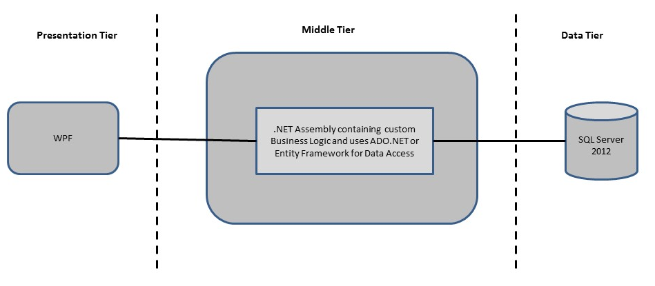

- Design guidelines
- All the exceptions/errors to be captured and user friendly message to be displayed on the CommonError page.
- Data access layer of 3-tier useADO.NET data access using SQL stored procedures - All the database interaction would be performed using Data Access Component. Most common methods in Data Access Component would be –
- Create Connection to the Database
- Create Command Object
- Set Command Type to Stored Procedure
- Create and Populate Parameters
- Execute the Command
- Close the Connection

Technology used:
    - Presentation Layer
      - WPF 4.5

    - Business Layer
      - Business Logic Components and Services :-
        - C# 5.0

    - Database Layer
      - Databases:-
        - SQL Server 2012

Sr. No | Course | Duration | Functionality to be built
Sr. No | Course | (in PDs) | Functionality to be built
1 | MS SQL Server 2012 | 4 | Creating relevant database tables and stored procedures
2 | NET Framework 4.5 + C# 5.0 | 7.5 | Developing Business components (C# classes)
3 | ADO.NET 4.5 | 3 | Integrating the DAL ,BLL and PL
4 | LINQ and Entity Framework | 2 | Creating data model and data context and using LINQ to Entities
5 | WPF 4.5 | 2 | Incorporating advanced UI functionality with WPF 4.5
6 | Mini Project Presentation | 1 | The Mini Project Presentation day

Note: Saturday half day will be devoted for mini project

Implementation

Summary of the functionality to be built:
The participants need to develop the Online Recruitment System Application by building the functionality incrementally in each of the course modules of .NET LOT.

Guidelines on the functionality to be built:
The functionality and components to be built in each of the course modules of .NET LOT is as follows:
- Course: SQL Server 2012
This section describes some of the basic steps involved in designing and creation of the database for the application.

Create Data Model - identify the different tables and fields that we will need, which would later be used for building the rest of the application.

Database Schema –
- Job Seeker can upload his resume
- Employer can add his details
- Both Employer and Job Seeker should search for a specific employee or Job based on the search criteria

Taking these objects, we can easily identify our main tables in the database.

  - Create the following database tables with following fields:[make your assumptions incase you require few more fields]
    - JobSeeker_Details: this will store all Job seeker details along with his resume and photo of the employee. [For e.g. Name, contact Details, Email, TelNo, Mobile No, and Address.

    - Employer details will store information of the company, employer clients, current openings, location of the openings, designation etc..

- Course: WPF 4.5
  - Develop the prototypes for following functionalities:
    - Login / Sign In: Login screen would display asking user to enter ‘User Id’ & ‘Passwd’. If the supplied user credentials are valid the HomePage would be displayed, else appropriate Login error message would be displayed
    - First time users Register: First time new users would use this screen to create their profile (userId and password). On click of ‘Submit’ button new user entry (user id & password) would be saved into database table for further user authentication purpose
    - Home Page: On successful user authentication (validation of userid/password provided by the user in login screen) the homepage would be displayed. The Homepage would contain below sections/contents:

Header section: The header section would be common across all the pages and would mainly have –

Sign In Link – On click it would take to Login page

Search: Should search based on Experience, Profession, SkillSet, Location, and Designation.

Main content section: It would display generic Welcome message giving overview of the site. Some Links to different companies based on the categories for example IT is one of the categories so the Web page should have a link for IT companies.

  - For Job Seeker :-
      - Once a job seeker has logged in he should see his resume and have option for modifying the resume.
      - Design a Page for Modifying the Resume of the Employee. It should also display a page how the employer’s will have a view of the resume.

  - For Employer:-
      - Once a Employer Login’s then all the details of the Employee should be visible and he should be in position to Update the details
      - Employer’s current openings should be also updated and displayed date wise sorted
  - In this course you need to develop the user interface using Winforms and WPF.The screens should include the fields as per the functionality mentioned above. Include Validations where ever required.

- Course: C# 5.0 and ADO.NET 4.5
  - Develop business components (C# classes) for the following functionality
    - Jobseeker_Details class :- This class will contain methods which will allow to add new jobseeker and maintain the details of the existing jobseeker
    - Employer :- This class will contain methods which will allow the employer to add the their details including job location, no of opening

You need to create Layered Architecture which comprises of PresentationLayer (winforms,WPF),Business Logic Layer (C# Classes) and DAL Layer(Using ADO.Net 4.5 or Linq and Entity Framework)

DAL Layer of ADO.NET 4.5 will include all the required code snippets for CRUD Operations.

All the CRUD operations should use SQL Server Stored Procedures(For Insert,Update,Delete & Search).

The connectionString should be stored in the configuration file only.
OR

- Course: LINQ and EF
  - Use database first approach to create entity data model based on the database created in the earlier steps which will consist of the following entities
    - JobSeeker_Details Class : This class will have all the details of the Job Seeker
    - Employer Class :- This class will have all the information about the employer including job location, no of openings
  - Use the Datacontext to perform CRUD operations and LINQ to implement the required logic (like retrieving data, sorting data, searching data etc).

- Course: ADO.NET 4.5 and WPF 4.5

      - Design the screens with Winforms,WPF 4.5
  - Integrate all screens (wpf) with business components (C# classes) to complete the entire functionality

Project Evaluation Guidelines
The project it is to be evaluated based on the following five parameters:

- Proper Database Structure and UI designing as per the specifications –(15 Marks)
  - Proper Database Design and Stored Procedure
  - Visual look and feel of the UI
- Project Completion – (20 Marks)
  - Timely Completion of the project
  - Integration of all component of the system
- Defect free execution – (30 Marks)
  - Error free execution of individual modules and the whole system
  - Validation
  - Functionality as per the specified requirements
- Compliance of standard and guidelines – (15 Marks)
  - Appropriate comments entries
  - Adherence to naming conventions for classes, functions, variables and files
  - Simplicity of user interface and screen layouts
  - Maintainability of codes (for example, no one function should be more than 100 lines)
- Group Presentation and Query handling – (20 Marks)
  - Participants (Group of 3 to 4) to present the project with UML Diagrams(use case diagram and one of the sequence or activity diagram) and PPT

